**File System Creation**

**What is the file system ?**

A **filesystem** is the methods and data structures that an operating **system** uses to keep track of **files** on a disk or partition; that is, the way the **files** are organized on the disk. The word is also used to refer to a partition or disk that is used to store the **files** or the type of the **filesystem**.

You can only have four primary partitions (with no extended partition) on a device. If you need more than four partitions, you can have three primary partitions, one extended partition, and multiple logical partitions within the extended partition.

**Creating a New Partition / File System :-**

1. Frist Check the Partition table using “fdisk” Command

# fdisk –l

1. Partitioning Device

# fdisk /dev/sdb

M

N

P

🡪 1 2 3 ..

Enter

+10G

P

Wq

# fdisk –l

# partprobe

1. Make a File System

# mkfs –t ext4 /dev/sdb1

or

# mkfs . ext3 /dev/sdb1

1. Create Mount Point

# mount /dev/sdb1 /mnt

# cd /mnt

1. Varify Mount Point

# df -hT

**Creating a Extended Partition:-**

1. Frist Check the Partition table using “fdisk” Command

# fdisk –l

1. Partitioning Device

# fdisk /dev/sdb

M

N

E

Enter

P

Wq

# fdisk –l

# partprobe

**Make a File System Permanent :-**

To make this Changes exists after system reboot or to make it paramanent then we have to edit “ /etc/fstab” file.

# vim /etc/fstab

/dev/sdb1 /mnt ext4 default 0 0

Note :- we can check which file system type is supported by linux Kernel in following Command

# cat /proc/filesystems

**Remove Partition :-**

1. Frist “umount” the partition which you want to Remove and Also remove the entry from “/etc/fstab”

# umount /mnt

1. Then use fdisk Command to delete the Partition

# fdisk /dev/sdb

M

D

P

Wq

# partprobe

**Converted Linux File System :-**

1. **Coverting ext2 to ext3**

# tune2fs –j /dev/sdb1

1. **Coverting ext2 to ext4**

# tune2fs -O dir_index,has_journal,uninit_bg /dev/hdXX

Next do a complete file system check with **e2fsck** command to fix and repair.

# e2fsck -pf /dev/hdXX

1. **Coverting ext3 to ext4**

# tune2fs -O extents,uninit_bg,dir_index /dev/hdXX

# e2fsck -pf /dev/hdXX

[**http://www.tecmint.com/how-to-check-disk-space-in-linux/**](http://www.tecmint.com/how-to-check-disk-space-in-linux/)

1. Check File System Disk Space Usage

[root@tecmint ~]# df

2. Display Information of all File System Disk Space Usage

[root@tecmint ~]# df -a

3. Show Disk Space Usage in Human Readable Format

[root@tecmint ~]# df -h

4. Display Information of /home File System

[root@tecmint ~]# df -hT /home

5. Display Information of File System in Bytes

[root@tecmint ~]# df –k

6. Display Information of File System in MB

[root@tecmint ~]# df –m

7. Display Information of File System in GB

[root@tecmint ~]# df -h

8. Display File System Inodes

[root@tecmint ~]# df –i

9. Display File System Type

[root@tecmint ~]# df –T

10. Include Certain File System Type

[root@tecmint ~]# df -t ext3

11. Exclude Certain File System Type

[root@tecmint ~]# df -x ext3

12. Display Information of df Command.

[root@tecmint ~]# df –help

**fdisk Commands to Manage Linux Disk Partitions**

1. View all Disk Partitions in Linux

[root@tecmint.com ~]# fdisk –l

2. View Specific Disk Partition in Linux

[root@tecmint.com ~]# fdisk -l /dev/sda

3. Check all Available fdisk Commands

[root@tecmint ~]# fdisk /dev/sda

4. Print all Partition Table in Linux

[root@tecmint ~]# fdisk /dev/sda

Command (m for help): **p**

5. How to Delete a Partition in Linux

[root@tecmint ~]# fdisk /dev/sda

6. How to Create a New Partition in Linux

[root@tecmint ~]# fdisk /dev/sda

7. How to Format a Partition in Linux

[root@tecmint ~]# mkfs.ext4 /dev/sda4

8. How to Check Size of a Partition in Linux

[root@tecmint ~]# fdisk -s /dev/sda2

9. How to Fix Partition Table Order

[root@tecmint ~]# fdisk /dev/sda

10. How to Disable Boot Flag (*) of a Partition

[root@tecmint ~]# fdisk /dev/sda

11.how to all partition in details

#Lsblk –f

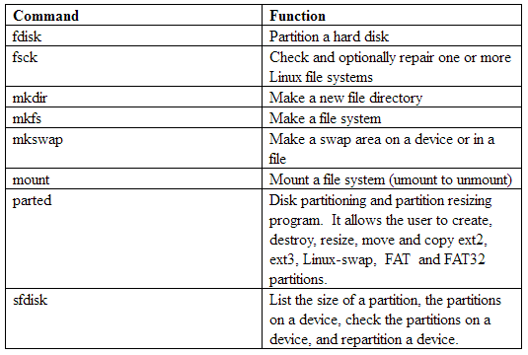

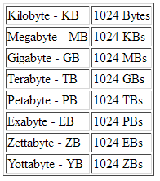

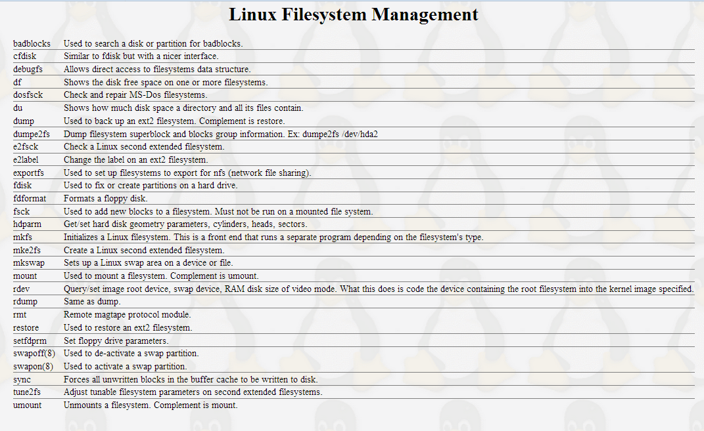

**For creating swap partition :**

# fdisk /dev/sdb

T

5

L

82

P

W

For create swap file

• Determine the size of the new swap file in megabytes and multiple by 1024 to determine the block size. For example, the block size of a 64 MB swap file is 65536.

• At a shell prompt as root, type the following command with count being equal to the desired block size:

dd if=/dev/zero of=/swapfile bs=1024 count=65536.

Setup the swap file with the command:

#mkswap /swapfile

To enable the swap file immediately but not automatically at boot time

#swapon /swapfile

To enable it at boot time, edit /etc/fstab to include:

/swapfile swap swap defaults 0 0

Test:

#swapon –s